EXERCISE-1
PL/SQL-Control Structures
Create Customers Table
CREATE TABLE Customers (
CustomerID NUMBER PRIMARY KEY,
CustomerName VARCHAR2(50),
Age NUMBER,
Balance NUMBER(10,2),
LoanInterestRate NUMBER(5,2),
IsVIP VARCHAR2(5)
);
Insert Sample Data
INSERT INTO Customers VALUES (101,'Rahul',65,15000,8.5,'FALSE');
INSERT INTO Customers VALUES (102,'Priya',45,8000,9.0,'FALSE');
INSERT INTO Customers VALUES (103,'Amit',70,12000,7.5,'FALSE');
INSERT INTO Customers VALUES (104,'Sneha',30,5000,8.0,'FALSE');
COMMIT;
Step 2: Create Loans Table
CREATE TABLE Loans (
LoanID NUMBER PRIMARY KEY,
CustomerID NUMBER,
DueDate DATE,
Amount NUMBER(10,2),
FOREIGN KEY (CustomerID) REFERENCES Customers(CustomerID)
);
Insert Sample Data
INSERT INTO Loans VALUES (1,101,SYSDATE+10,50000);
INSERT INTO Loans VALUES (2,102,SYSDATE+40,60000);
INSERT INTO Loans VALUES (3,103,SYSDATE+20,70000);
INSERT INTO Loans VALUES (4,104,SYSDATE+5,30000);
COMMIT;

Scenario 1: The bank wants to apply a discount to loan interest rates for customers above 60 years old. Question: Write a PL/SQL block that loops through all customers, checks their age, and if they are above 60, apply a 1% discount to their current loan interest rates.
DECLARE
BEGIN
FOR c IN (SELECT CustomerID, Age, LoanInterestRate FROM Customers)
LOOP
IF c.Age > 60 THEN
UPDATE Customers
SET LoanInterestRate = LoanInterestRate - 1
WHERE CustomerID = c.CustomerID;
END IF;
END LOOP;
COMMIT;
END;
/
SELECT * FROM Customers;
OUTPUT:
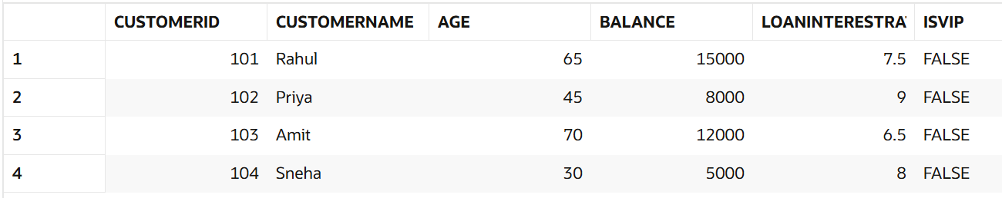
Scenario 2: A customer can be promoted to VIP status based on their balance.Question: Write a PL/SQL block that iterates through all customers and sets a flag IsVIP to TRUE for those with a balance over $10,000.
DECLARE
BEGIN
FOR c IN (SELECT CustomerID, Balance FROM Customers)
LOOP
IF c.Balance > 10000 THEN
UPDATE Customers
SET IsVIP = 'TRUE'
WHERE CustomerID = c.CustomerID;
END IF;
END LOOP;

COMMIT;
END;
/
SELECT * FROM Customers;
OUTPUT:
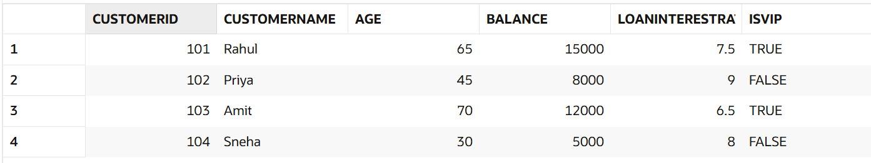

Scenario 3: The bank wants to send reminders to customers whose loans are due within the next 30 days.
Question: Write a PL/SQL block that fetches all loans due in the next 30 days and prints a reminder message for each customer.
SET SERVEROUTPUT ON;

DECLARE
BEGIN
FOR l IN (
SELECT c.CustomerName, l.DueDate
FROM Customers c
JOIN Loans l
ON c.CustomerID = l.CustomerID
WHERE l.DueDate BETWEEN SYSDATE AND SYSDATE + 30
)
LOOP
DBMS_OUTPUT.PUT_LINE(
'Reminder: Loan payment is due for '
|| l.CustomerName ||
' on ' ||
TO_CHAR(l.DueDate,'DD-MON-YYYY')
);
END LOOP;
END;
/
OUTPUT:
